Portfolio Milestone

Syracuse University

Tiffannie Mac Donald

SUID: 971615542

March 30, 2021

Projects

[Current Resume](https://www.linkedin.com/in/tiffanniemacdonald/detail/overlay-view/urn:li:fsd_profileTreasuryMedia:(ACoAABQVp5UBF5Y-wR4CrBUYNgtRz5EC-dnnHb8,1608607033206)/)

Table of Contents

Introduction 3

Review & Overview of the Major Practice areas of Data Science 3

Background 4

Collect & Organize Data 4

Problem to be Solved 4

Data Questions 4

Background 5

Tools & Techniques Used 5

Analysis and Insights 5

Identify Patterns in Data: Visualization, Statistical Analysis, & Data Mining 8

Problem to be Solved 9

Data Questions 9

Background 9

Tools & Techniques Used 9

Insight Gained 16

Develop Alternative Strategies based on the Data 18

Problem to be Solved 18

Data Questions 18

Background 18

Tools & Techniques Used 19

Analysis & Insights 20

Develop a Plan of Action to Implement the Business Decisions derived from the Analyses 28

Demonstrate Communication Skills regarding Data and its Analysis 28

Synthesize the Ethical Dimensions of Data Science Practice 29

# Introduction

This document is a report to show that the seven learning objectives set by Syracuse University have been successfully met. The Applied Data Science curriculum as developed by Syracuse has provided the appropriate skills, background, learning opportunities, resources, and knowledge to prepare me to enter the field of data science as a proficient data scientist. This document will illustrate how all seven learning objectives were met and provide the projects and examples completed throughout the course as evidence. The program’s objectives will be explained and include a synopsis of three of my projects that highlight the corresponding learning objectives.

Applied Data Science Program Learning Objectives:

1. Describe a broad overview of the **major practice areas** of data science. (Data Mining, Predictions)
2. **Collect and organize** data.
3. **Identify patterns** in data via visualization, statistical analysis, and data mining.
4. **Develop alternative strategies** based on the data.
5. Develop a plan of action to **implement the business decisions** derived from the analyses.
6. **Demonstrate communication skills** regarding data and its analysis for managers, IT professionals, programmers, statisticians, and other relevant professionals in their organization.
7. Synthesize the **ethical dimensions** of data science practice (e.g., privacy).

# Review & Overview of the Major Practice areas of Data Science

There are three major practice areas of data science: descriptive, predictive, and prescriptive analyses. Data Science is a broad field of analyzing vast quantities of information that goes beyond the realm of descriptive analytics. To tell the story of what “has happened” in data, descriptive analytics is used. Descriptive analytics helps us measure what is happening over time and understand trends. This primary type of analysis relies on fundamental statistics metrics such as mean, median, standard deviation, quartiles, etc. The goal with Descriptive statistics is to showcase and visualize trends over time.

The next aspect of data science is predictive analytics which goes a step forward after descriptive statistics. Descriptive analytics has its limitations. The biggest limit is this simple analysis is confined to only using past data. On the other hand, predictive analytics allows practitioners to “predict” trends in data. These trends include data forecasting, predicting data values of missing attributes in a set of data (which is also called supervised learning), classifying or identifying unlabeled targets (this is known as unsupervised learning), and the impact changing data on future trends (this is semi-supervised learning). Housing price analysis and movie review sentiment analysis are a few examples of predictive analytics. Housing price analysis studies past housing market behavior and home price trends to predict the price of a home with certain attributes. These analyses produce a dollar value signifying how much the home is worth based on qualities such as city, number of bedrooms, other amenities, etc. Text sentiment analysis is studies text to predict emotions elicited by the words/language in the text. The goal is to measure if the language is positive or negative or, possibly, another emotion. The measuring scale is, generally, rating the text between negative 1 to positive 1. A positive score indicates that the text elicits a positive sentiment and vice versa.

The final type of analysis within the data science realm is prescriptive analytics. Prescriptive analytics provides possible solutions and showcases the impact pursuing various solutions on future trends. It is considered the goal of any data science project: to provide possible solutions. Prescriptive analysis is a somewhat limited, but ever-evolving discipline. This type of analysis still has valuable applications in business.

Spotify’s music recommendation system is a great example of prescriptive analytics. It analyzes the user preferences and provides recommendations for new or different music. This system views user trends, provides new artists and “vibes” based on user behavior. In this way, it functions like a personal DJ by using data analysis for a music listening experience. Self-driving cars are also an example of prescriptive analytics. By taking in data via sensors and past driving data, the car “chooses” where to go and what is safe.

## Background

The following selected projects from the program provide examples of the major practice areas of data science as described above. From collecting data and creating an effective business plan, to developing analytical approaches, to discovering patterns and clearly communicating to a team of people of different technical backgrounds, and, finally, how to navigate ethical responsibilities that data scientists face day to day.

These projects will demonstrate examples of supervised learning, unsupervised learning from a technical perspective.

# Collect & Organize Data

This learning objective was covered through, basically, all the projects assigned in the program. I have developed the skill necessary for data collection and cleaning. The following project is from my Advanced Data Analytics course (IST 718). In this project, data was collected from an API, different data sets, and all combined to create a dataset that would help provide insight into UFO Sightings.

## Problem to be Solved

### Data Questions

* What areas of the country are most likely to have UFO sightings?
* Are there any trends in UFO sightings over time?
* Do clusters of UFO sightings correlate with landmarks such as airports or military bases?

### Background

Unidentified Flying Objects or UFO’s have been the subject of much scrutiny over the years. The purpose of this project was to observe any patterns of UFO reports and be able to make predictions as to when the next may occur.

To gain a comprehensive look at all factors that may contribute or affect the legitimacy of a UFO sighting. Our base data came from a UFO dataset from the NUFORC which was found on Kaggle. This set contained recorded instances and measures given by witnesses of UFO encounters. There were many attributes including date, time, duration, shape of the UFO, etc. This assignment was also designed to make us include other datasets. We included weather data, alien related movie releases via the TMDB movie API, drug and alcohol consumption, and airport and military base information. We wanted to know what areas of the country were most likely to have sightings, if there were any trends in UFO sightings over time, if distance to air bases were significant, and to also build classifiers to determine which attributes were most predictive of a UFO sighting.

## Tools & Techniques Used

The script was written using Python and the Jupyter Notebooks IDE.

This project required a variety of data aggregation and data frame combining techniques in Python. The Python library, Pandas, was of much use in this project. Combining datasets required the exploratory analysis of each dataset, learning about application programming interfaces or API’s (reading JSON data with Python and cleaning it), and filtering relevant data features to match up with each sighting. The final data frame consisted of a comprehensive look into many features that could contribute to UFO sighting that were not included in the original dataset provided on Kaggle. A total of 10 datasets were read in, explored, cleaned, visualized, and combined to come to provide insight into UFO sightings.

## Analysis and Insights

Exploratory analysis of the original dataset revealed UFO sightings have increased significantly in the last 30 years.

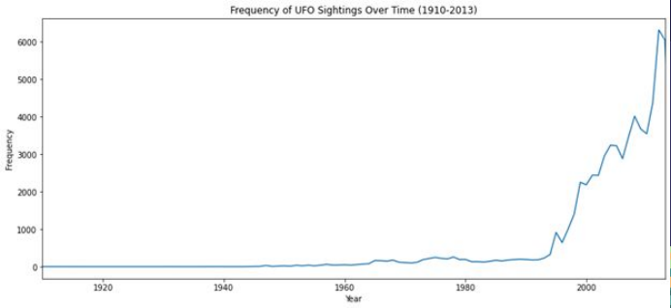

Figure 0. Frequency of UFO Sightings Over Time

We went through and created many visualizations of the various datasets to see if there were any correlations between the sightings and other events (population, weather, distance to aviation bases, proximity to movie releases, etc).

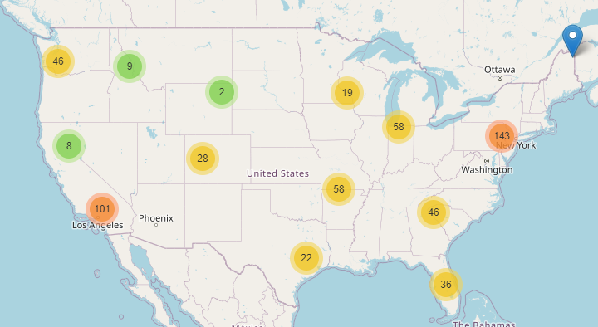

Figure 1. Interactive Maps Generated to view Number of Sightings per City and State

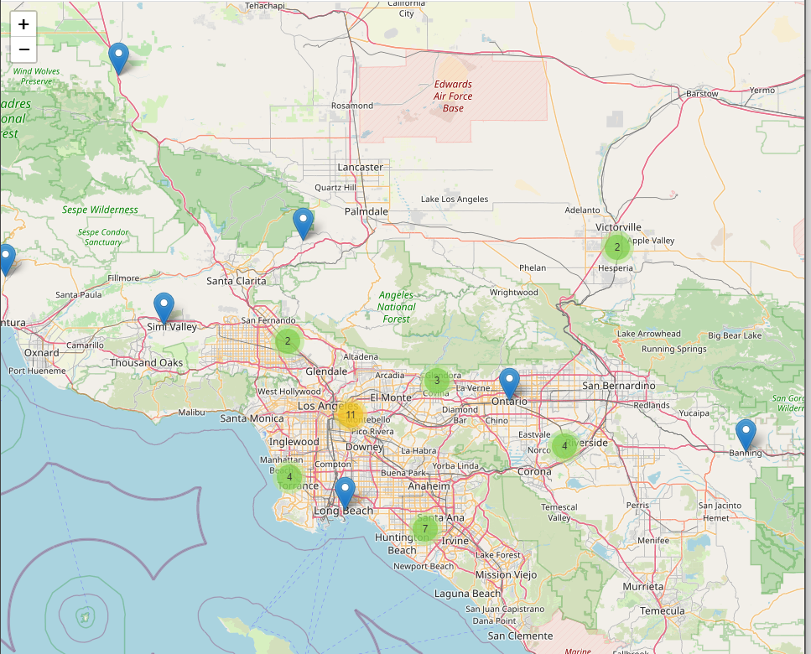

Figure 1.1: A Zoomed-In View of the Interactive Map to the Los Angeles Area. Each Blue Marker is the Location of a UFO Sighting

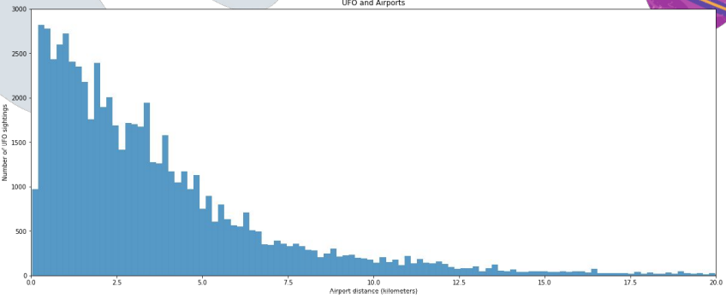

Figure 2. Histogram of Sightings in Comparison to Distance to Airports

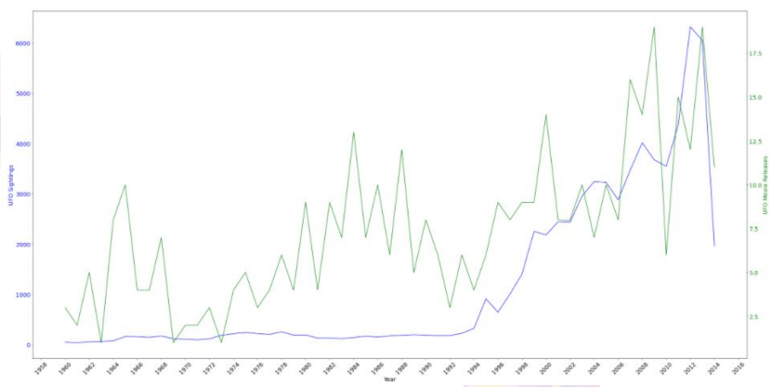

Figure 3. Line Plot Comparing UFO Movie Releases and UFO Sightings

We combined the datasets and created a metric called “Credible” which flagged a sighting as a credible event or not. Disqualified sightings were those which occurred on special holidays, under extreme weather conditions, and within a certain range of airports or military bases.

We used a variety of machine learning models to return something called “feature importance” which tells us which features were most useful in predicting a sighting. The most common feature that was most important across the models was the distance of the sighting to an airport. Some of our recommendations for increasing the likelihood that you could witness a UFO sighting included spending time outside during the summer in a big city (somewhere in California since the most sightings were reported there). If you wanted to really increase your chances, go out on the fourth of July while intoxicated.

# Identify Patterns in Data: Visualization, Statistical Analysis, & Data Mining

This learning objective was refined over the course of the program. Many of projects assigned in this program challenged me to develop skills with data visualization, statistical analysis, and data mining. The Introduction to Data Science (IST - 687) and Data Analytics (IST - 707) courses provided me with the necessary tools to familiarize myself with R and RStudio. My Advanced Data Analytics course (IST 718), as mentioned above, challenged my skills with machine learning and where I refined my ability to extract key features from a machine learning model to gain insight about any underlying processes. One of the hardest courses I took, an Advanced Text Mining class (IST 736), provided many opportunities to hone these skills. I will showcase below how I learned how to do these techniques with text data, which was a very difficult task. In this project, the news articles were imported from various sources using Python API packages/Jupyter Notebook and cleaned and analyzed to produce the following classification analysis.

## Problem to be Solved

### Data Questions

* Is it possible to avoid bias by consuming media from multiple news sources?
* Can we perform topic classification for each news article?
* These tasks can be completed in two parts.
  + First, news articles across various sources need to be categorized by their topics.
  + Next, from these articles of the same topic, the main idea will be extracted, giving a high-level overview of what is going on in the world in regard to that subject. By taking the high-level topic, across multiple sources, bias will ideally be largely removed. With bias mitigated, a concise resource for current events and news can be produced.

### Background

Bias is often unavoidable, a fact increasingly obvious in news reporting and journalism. According to a survey conducted by the Pew Research Center in Spring 2019, 50% of Americans say made-up news or information is a very big problem in the United States. This ranks higher than issues like violent crime and climate change.

However, it is unclear how to mitigate this problem. According to the same survey, 63% of Americans have stopped getting their news from a particular outlet and 43% have lessened their overall news intake. While this may lower the amount of false information consumed, total avoidance of world issues is undesirable.

A possible solution is to consume media from multiple news sources, with various political affiliations. By reading reporting from different sources, the mutually reported information will likely be closer to fact. However, the task of consuming multiple times the standard amount of media is infeasible for the average person. Instead, the hope is to produce a programmatic procedure to gather news topics, devoid of bias.

## Tools & Techniques Used

A labeled corpus of news articles was collected as a training set. The articles were gathered from news sources with varying affiliations and perspectives. In addition to coming from various sources, these articles were labeled as pertaining to one of five topics: business, sports, entertainment, politics, and medical.

When collecting news articles from various sources, it was apparent that the data was heavily skewed toward politically-based topics as the United States presidential election was taking place at the time of data collection. In addition, discussion of COVID-19 (medical in nature) occurred throughout all topics. To account for these issues, additional articles were collected from specialized media sources.

The sources used are listed in the table below, along with the topics gathered from each source.

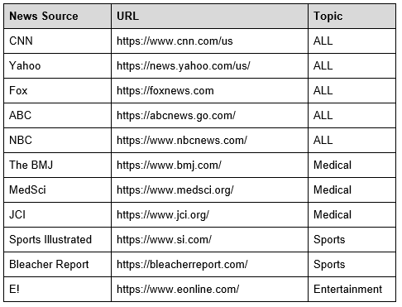

Table 1. News Article Sources

With the articles collected, their text contents need to be cleaned. This is standard with any text mining projects. URLs are filtered, all words are made to be lowercase, and a series of symbols are removed. Tokenization is the next step in the mining process. A tokenizer is a tool that assembles a set of rules about how to group characters into individual tokens. For this experiment, each word in each sentence was treated as a token. Regex is used to tokenize the articles. The regex pattern takes any number of alphanumeric symbols surrounded by white space as a word. Stemming or lemmatization can be utilized to reduce the dimensionality of a corpus, or group of documents, by combining related tokens. Both techniques were explored in this experiment. Stemming is a process where words are reduced to their root forms. This is performed by dropping unnecessary characters from each token, usually a suffix.

Lemmatization is a similar technique to stemming. Whereas stemming only looks at the form of the word, lemmatization looks at the word meaning. After stemming and lemmatizing are used, vectorization is performed. The unique tokens in the corpora were gathered in a list after tokenization to be used as the vocabulary. After the vocabulary was defined, each text article was converted into a vector, where each non-zero entry represents an item in the vocabulary.

In the following table, a summary of the tokens making up the corpora are displayed. The counts are displayed both before and after the filtering, tokenization, stemming, and lemmatization steps.

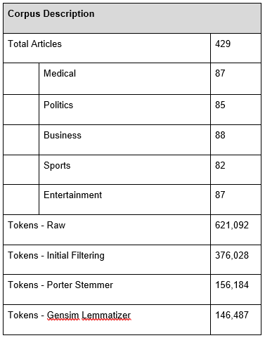

Table 2. News Article Corpus Description

After the vocabulary was defined, each text article was converted into a vector where each entry represents an item in the vocabulary. For this experiment, two vectorizers were utilized: binary and Term Frequency-Inverse Document Frequency (tf-idf). The binary representation checks for word presence only, meaning each token in the vocabulary has either occurred (1) or not occurred (0) in each document. The tf-idf representation relates the term frequency (frequency of a term in each document) to the document frequency (number of documents a term occurs in). This gives a measure of the importance of each term to each article in the corpora.

Four versions of each model type were produced with the four combinations of data preparation discussed above. These included the two vectorizers, binary and tf-idf, and the stemmed and lemmatized corpora. All model types were be trained and tested with these four sets of data and those with the best performance (most accurate classification results) will be discussed in the below.

Unsupervised Learning

To get a sense for the natural grouping of the data, unsupervised learning is utilized. Ideally, this will support the labeling performed on the dataset. In this research, k-means clustering is used to split the data into clusters. K-means does this with a defined number (k) of clusters around a series of centroids.

Blind to the known labels, k-means clustering was used to confirm the natural grouping of the articles. In figure 4 below, the manually labeled corpus is visualized. In figure 5, the clusters generated by k-means are visualized. The clustering using k-means appears to be heavily dominated by one cluster. However, the model appeared to have correctly identified two closely clustered sections: a group of entertainment articles (at the top of figure 4, in red) and a group of sports articles (to the left of figure 4, in orange). The natural separation between political, business, and medical articles appeared to be less easily identifiable.

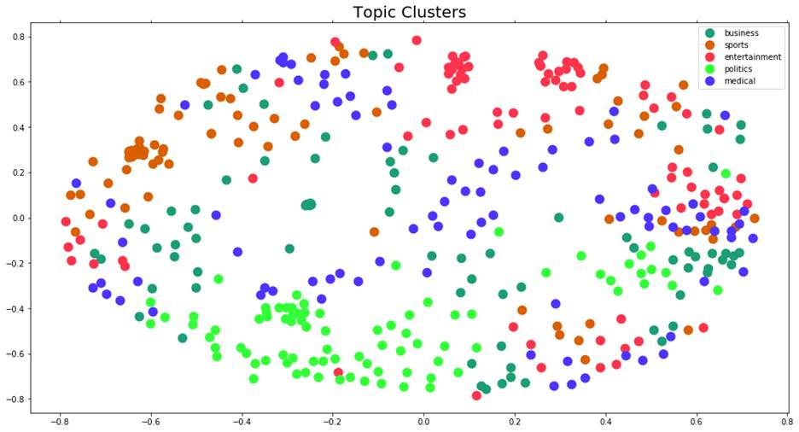

Figure 4: Cluster Visualization - Labeled Data

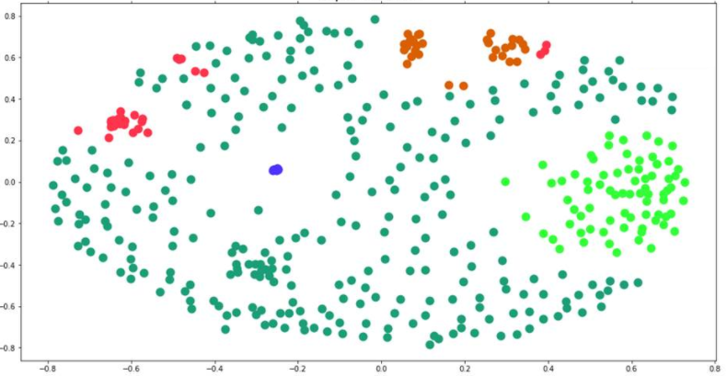

Figure 5: Cluster Visualization- K-Means Clustering

To get a better idea of the contents of each manually labeled cluster, a group of word clouds were generated (figures 5-9). In addition to describing the contents of the training corpus, these word clouds give an idea of the type of results that can be generated for future applications. When an accurate model is identified, new articles may be gathered and labeled programmatically. Then, word clouds such as these may be produced using the new, machine-labeled corpora.

Figure 5: Medical Word Cloud Figure 6: Entertainment Word Cloud

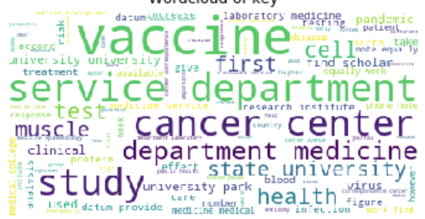 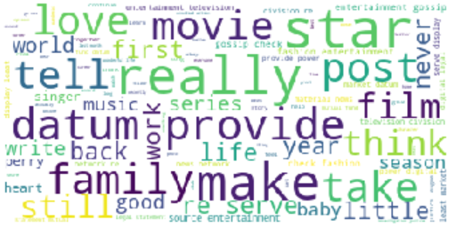

Figure 7: Politics Word Cloud Figure 8: Business Word Cloud

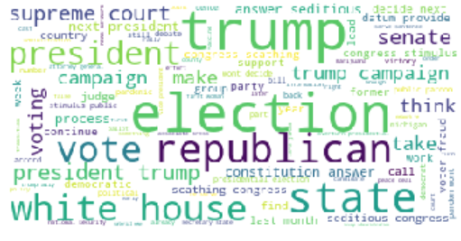 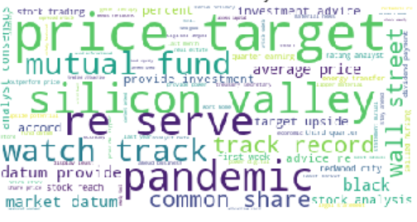

Figure 9: Sports Word Cloud

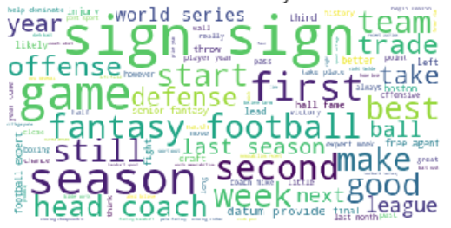

Based on the labels predicted using k-means clustering, as well as the known labels, a selection of topics were produced using Gensim topic modeling. Below, those topics are displayed. In the predicted clusters, cluster 0 appears to contain articles about medical data and cluster 2 appears to contain articles about sports. However, the topics of clusters 1, 3, and 4 are less obvious. In contrast, even without knowing the label used to produce each group, the topics of the known label groups are easily identified. In order, these are identified as: business, entertainment, medical, politics, and sports. Given the superior performance of the manually labelled data, the goal going forward was to create a supervised model which could replicate the manual labeling in an automated way.

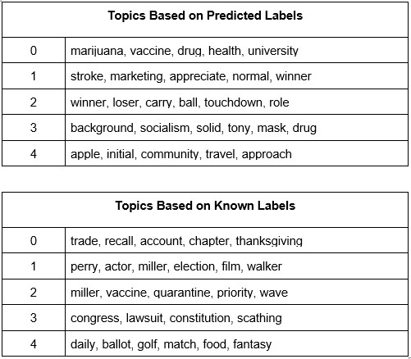

Supervised Learning

To predict the topic of each article, train test splits of the labeled corpora were created. The training sets were used to produce a series of models. For this research, Multinomial Naive Bayes (MNB), Bernoulli Naive Bayes (BNB), k-Nearest Neighbors (kNN), Support Vector Machines (SVM) with various kernels, decision trees, and random forests were produced. Each model was run with all four versions of the corpora discussed above.

In total, 32 combinations of models and corpora were produced. These were made up of combinations of the eight model types and the four vectorized text combinations. The best results were found when using the Gensim lemmatizer over the Porter stemmer. The average accuracies for the eight models produced for each vectorization method using the Gensim lemmatizer are summarized below (figures 10-11).

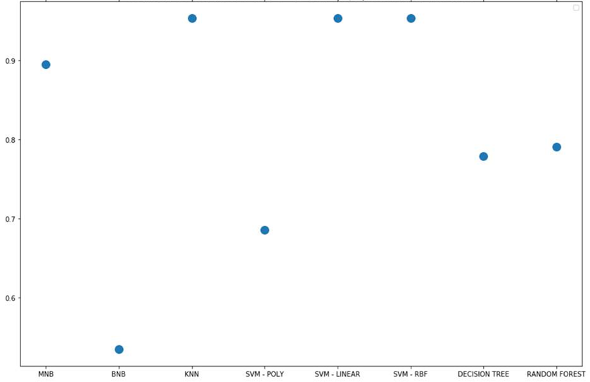

Figure 10: Model Accuracies (Gensim Lemmatizer & TFIDF Vectorization)

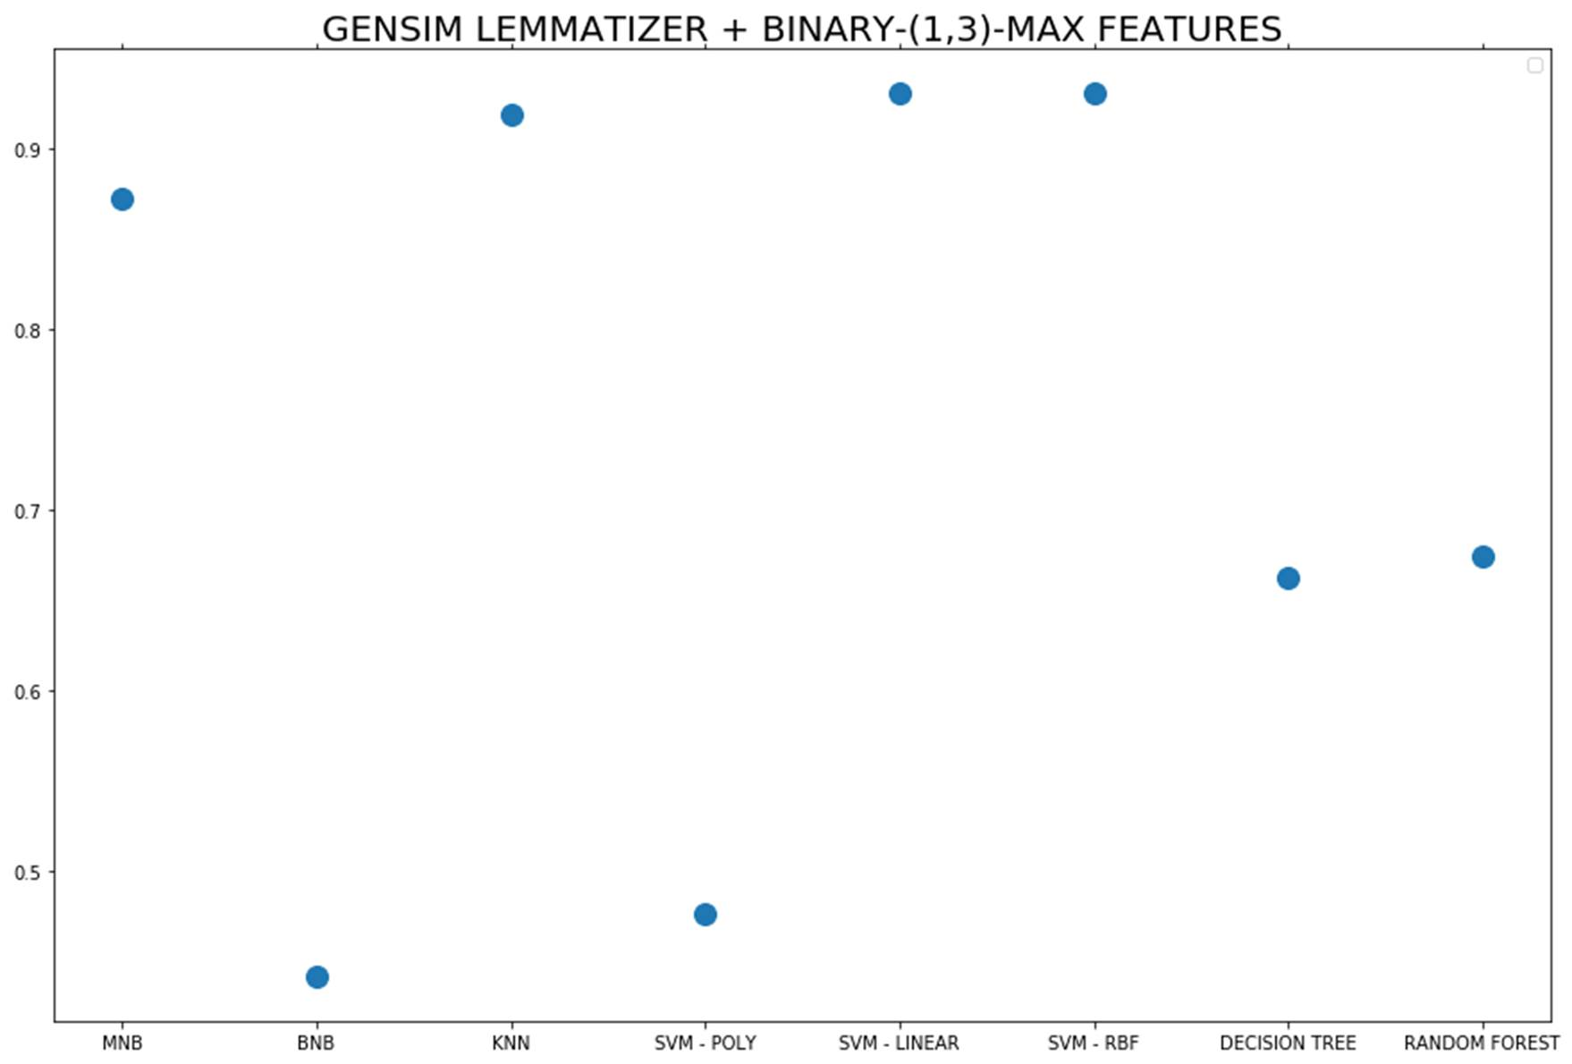

Figure 11: Model Accuracies (Gensim Lemmatizer & Binary Vectorization)

When using both the tf-idf and binary vectorized versions, the best results were found when using the linear kernel SVM, radial kernel SVM, or kNN. The Multinomial Naive Bayes model followed closely behind in both cases. While the SVM and kNN models had great results, the Multinomial Naive Bayes model is better suited to this task for two reasons: runtime complexity and feature ranking. The feature ranking provided by Multinomial Naive Bayes was better suited for this task. This means that the model highlighted which tokens were most indicative of each news topic. As the goal of this task was to understand the contents of each topic, feature ranks were useful.

## Insight Gained

The Naive Bayes model fit to a 99% accuracy which likely overfitted to our data. However, the hyperfit feature selection was very indicative of the high level summary of each topic. Below, the top features from the improved Multinomial Naive Bayes model are displayed for each topic.

|  |  |  |  |  |
| --- | --- | --- | --- | --- |
| **Improved Naive Bayes - Top Features** | | | | |
| **Medical**  **(1082 features)** | **Politics**  **(1876 features)** | **Entertainment**  **(1162 features)** | **Business**  **(4235 features)** | **Sports**  **(1459 features)** |
| vaccine | trump | entertainment | stock | coach |
| health | election | actor | company | season |
| care | president | movie | investment | fantasy |
| study | republican | music | dividend | team |
| testing | senate | perry | oracle | football |
| disease | fraud | check fashion | business | sport |
| medicine | campaign | check fashion entertainment | analyst | fantasy football |
| test | court | division re | homology | game |
| drug | presidential | division re serve | price target | player |
| blood | trump campaign | entertainment gossip | income | fantasy football expert |

Overall, this experiment produced extremely promising results. When considering articles about business, sports, entertainment, politics, and medicine, this method was able to correctly determine a topic in over 90% of cases and was able to generate high level key words surrounding the topics. The table below shows the words that were determined as important to each topic for the articles used in the experiment.

|  |  |  |  |  |
| --- | --- | --- | --- | --- |
| **Medical** | **Politics** | **Entertainment** | **Business** | **Sports** |
| vaccine | trump | entertainment | stock | coach |
| health | election | actor | company | season |
| care | president | movie | investment | fantasy |
| study | republican | music | dividend | team |
| testing | senate | perry | oracle | football |
| disease | fraud | check fashion | business | sport |
| medicine | campaign | check fashion entertainment | analyst | fantasy football |
| test | court | division re | homology | game |
| drug | presidential | division re serve | price target | player |
| blood | trump campaign | entertainment gossip | income | fantasy football expert |

By looking at just these high level keywords, a general view of the current news climate can be gleaned. These results were representative of the type that would be produced in further applications using this method. The goal of this process was to obtain a very high level overview of current events devoid of bais. By looking at only key phrases, there is little room for opinion.

# Develop Alternative Strategies based on the Data

Assuming alternative strategies means being delving into different methods of analysis due to subpar performance of the initial process, while the text mining project above demonstrates this principle, there is another project that allowed me to explore this lesson. The following example comes from my IST 707 Class. I gained knowledge to explore different routes when presented a data set. In data science, there may not be a cut and dry approach to tackling questions and research. Using R, I learned how to approach a dataset and extract pertinent information to answer questions to a real life problem. While the results were less than “ideal,” this was a great learning opportunity to test our ability to search the internet for troubleshooting and model adaptations. It was very encouraged to search and learn on our own throughout this program. In this project, the raw comma separated value or CSV files generated from a study done by the Department of Information Systems at the University of Minho, Portugal. The data was read in to RStudio, an R IDE, and cleaned and analyzed to produce the analysis below.

## Problem to be Solved

### Data Questions

* Can we predict the likelihood of forest fires?
* Is there a correlation between certain environmental factors and forest fires?

### Background

Each year, uncontrollable wildfires cause great devastation to our environment, ecology and economy. They put many that sacrifice to contain the fires at risk and kill many helpless animals. These affected areas take several years to recover from the damage and impact left behind, costing governments billions of dollars to address.

Meteorological data is often collected automatically with instruments placed throughout an area. These instruments can collect data on criteria such as wind speed, humidity, rainfall, and other such environmental characteristics.

Natural weather phenomena have great ecological impact- displacing people, and impacting animal populations. Changing climate conditions could mean that the frequency of these events is ever-increasing, urging a necessary evolution in the way we collect, analyze, and make predictions on weather data. Forested areas are vitally important to the health of the planet, contributing oxygen and humidity, and regulating soil quality to prevent other phenomena like landslides. Protecting forested areas is as important to the health of the planet as well as the well-being of local populations.

Meteorologists were tasked with helping to predict when fires may become prevalent during certain weather conditions. Whenever a wildfire was observed, specific data was collected in hopes that the data could help determine fire watch conditions.

The Fire Weather Index (FWI) was created in 1992 to estimate the risk of a wildfire. The index was computed by Meteo France and the Meteorological Service of Canada. It was first introduced in France and was based upon a Canadian empirical model that has been in place since the 1970’s. The meteorological data that was collected for use in the model are temperature, relative humidity, wind, and rainfall amount. Along with the meteorological data, three fuel moisture codes were collected, the Fine Fuel Moisture Code (FFMC), Duff Moisture Code (DMC) and Drought Code (DC). Together with the meteorological data, they yield the Fire Behavior Indices, Initial Spread Index (ISI) and Buildup Index (BUI) which are combined to compute the overall Fire Weather Index (FWI).

A forest fire data set sourced from the UCI Machine Learning Repository, utilizing a combination of meteorological data and spatial coordinates were used to provide insight about forest fires in Montesinho Park, located in the northeast region of Portugal.

Analysis of this dataset will use data mining techniques, such as classification methods including Decision Tree Analysis, Naive Bayes, Support Vector Machines and Random Forest to identify the combination of values that contribute to the likelihood of a significant forest fire.

## Tools & Techniques Used

The script was written in R with the RStudio IDE. The data consisted of many variables including the x and y coordinates of the fires, the month, day, FFMC, DMC, DC, ISI, the temperature in celsius, the relative humidity on a scale between 15 and 100 percent, the wind speed, amount of rain, and the area burned.

The Fine Fuel Moisture Code (FFMC) refers to the moisture level and is an indicator of the flammability of fine fuel. The Duff Moisture Code (DMC) also refers to moisture and fuel consumption rate in soil and organic layer composition. The Drought Code (DC) is a moisture rating of deep organic layers and is an indicator of smoldering effects in large logs. The Initial Spread Index (ISI) is a rating of expected fire spread.

The data was read into R as an excel file, containing 13 different continuous and categorical variables and a total of 517 observations spanning 12 months. In addition to the attributes mentioned above, the data includes the month, day of the week, X longitude and Y latitude coordinates of Montesinho Natural Park at the time of a fire. Within each variable, there were no observed null values which resulted in the data being fairly clean. At this time, additional preprocessing steps were taken to determine the best format of the data for all model requirements.

The first observation is of the area variable containing many zero values. Upon further research, the zero value represents the amount of area burned in the park being less than 1 hectare. It should be noted that an additional binary feature is created to represent an “insignificant” fire with a zero. The definition of an insignificant fire is defined as covering less than .1 hectares, and a 1 to indicate a “significant” fire greater than .1 hectares. This variable is used during the classification models

Secondly, the data proposed a challenge as each variable was measured by its individual index. In addition to this, the variables FFMC, ISI, rain, and area displayed a certain amount of skewness. To optimize the performance of the distance-based models used, the data was normalized by utilizing the min-max scale of the values. Four datasets were created: one being the original dataset with the acquired significant feature, a separate dataset for the scaled data, and the last two datasets were created by doing a 67:33 training test split to run through machine learning models.

## Analysis & Insights

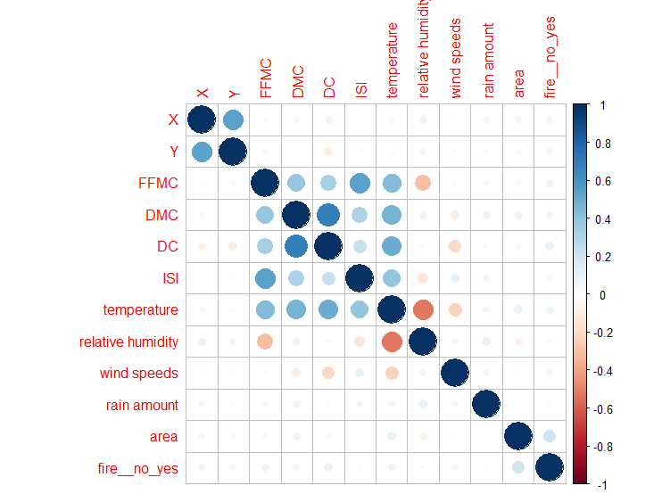

Figure 12: Correlation Matrix of Variables

There were no strong correlations between variables and if there was a fire that day or how much of the area was burned.

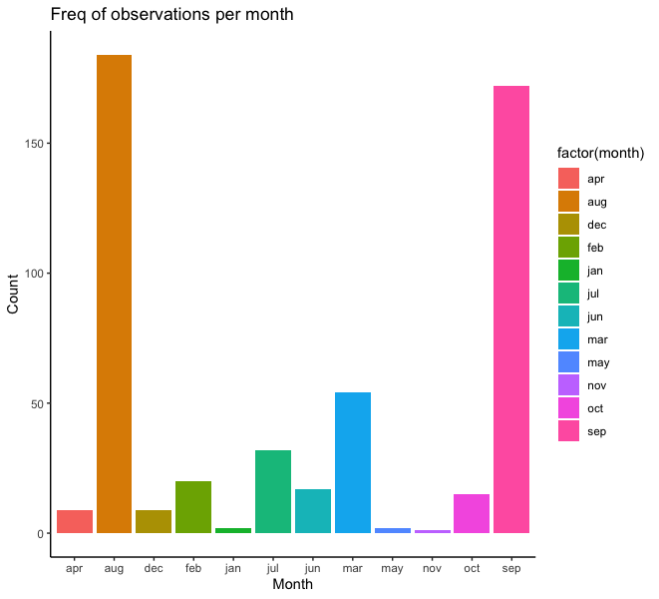 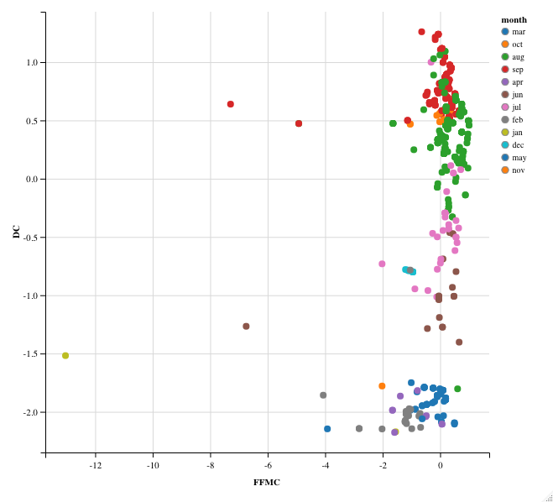

Figures 13 & 14. Scaled DC & FFMC (All Data)

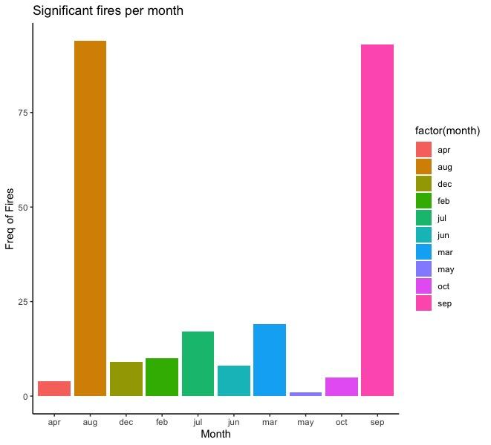 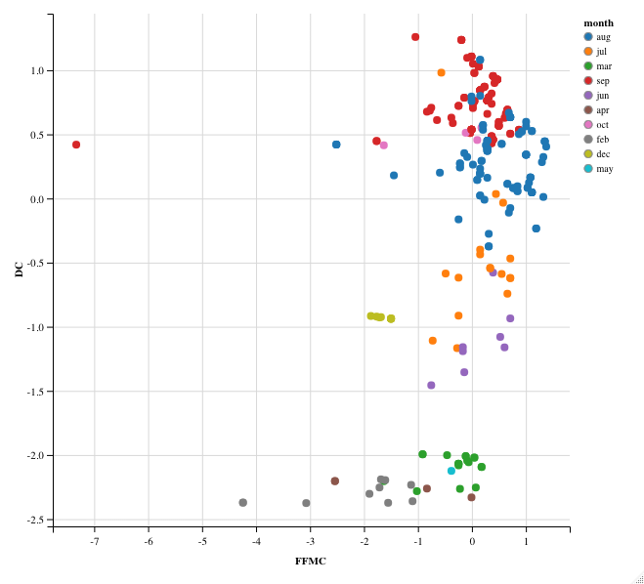

Figures 15 & 16. Scaled DC & FFMC (Significant Fires)

The exploratory data analysis revealed that forest fires occur the most in the months of August and September. Furthermore, the drought code and Fine Fuel Moisture Code are above average in these two months for the significant fires occurring. The FFMC and DC are key factors for fire behavior. Last but not least, after February the drought code begins having an exponential growth curve, and the Fine Fuel Moisture Code begins seeing a subtle positive increase as well.

To further explore the causes behind the forest fires in Montesinho Natural Park the K-means algorithm is utilized. The euclidean distance is the measure used in the k-means algorithm. The goal for the k-means clustering is to find homogeneity within clusters and heterogeneous across clusters. In other words, the key operation is the computation of the distance between two cluster centroids. Resulting in the smallest sum of squares being chosen as the most optimal number of clusters.

In this exercise, the application of the k-means algorithm is being used to narrow down the transitional points in time when environmental conditions foster more frequent significant fires.

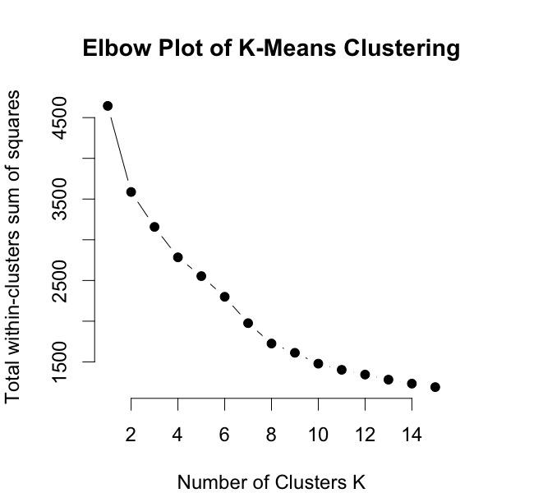

Figure 17: K-Means Model Elbow Plot

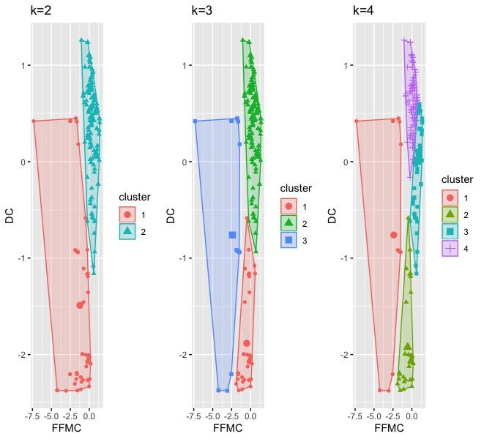

Figure 18: K-Means Results

The k-means clustering results suggest that there were well defined points in time where an increase in the frequency of fires were prone to occur more often in provisional situations. The conditions captured in cluster 2 show a group of significant fires with a below average FFMC index and a below average DC index. It is to be noted there are a few outliers and if removed the clusters will likely produce less cloudy results.

Decision Trees Model

Three different decision trees were generated to investigate which of the attributes would best predict a significant burn area. The trees were varied according to R’s set.seed() parameter for reproducibility, and utilized cross-validation. Information Gain was also performed to assess the importance of each variable.

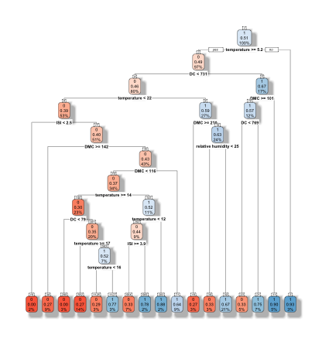

Figure 19: First Decision Tree Resulting Graph. Seed = 123

set.seed(123) had an accuracy of 51% and reflected a 21% chance of a significant burn area when the Relative Humidity less than 25. Information gain showed that Temperature was the most important variable. This tree first split at Temperature, then branched into DC, then Temperature and DMC.

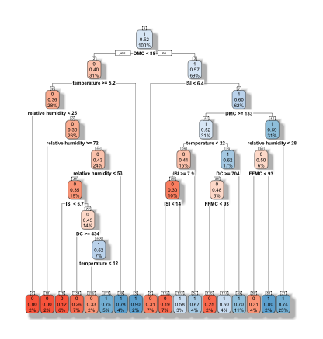

Figure 20: Second Decision Tree Resulting Graph. Seed = 1016

set.seed(1016) had an accuracy of 52% with a 25% chance of a significant burn area when the Relative Humidity was less than 28. Information Gain showed that DMC was the most important variable. This tree first split at DMC, then branched into Temperature and ISI.

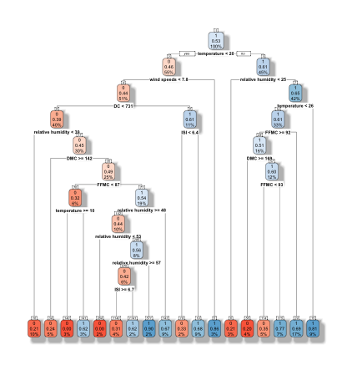

Figure 21: Third Decision Tree Resulting Graph. Seed = 69

set.seed(69) reflected a 17% chance of a significant burn area when the FFMC was greater than or equal to 92. Accuracy was measured at 53%. This tree first split at temperature, then branched into wind speeds and relative humidity. Information gain showed that Temperature was the most important variable. This tree first split at temperature, then branched into wind speeds and relative humidity.

Random Forest Model

The random forest model was used as well for prediction. The number of trees used was 400. The number of splits the model allowed for was 6.

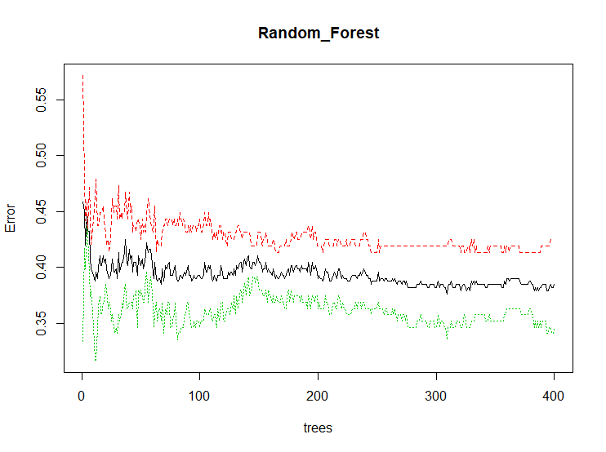

Figure 22: Random Forest Model Error Evaluation



Figure 23: Random Forest Model Resulting Confusion Matrix

The random forest results were a 55% accuracy. The false negative error is the lowest of all models at 49%.

Logistic Regression Model

The logit logistics model was used to predict significant fires using all of the available variables and checking for statistical significance. A statistical significance level of .095 was used for determining what dependent variables to use.

Figure 24, below, shows the results from the logistic regression. None of the variables come close to being significant. DC comes in closest, but was still not significant.

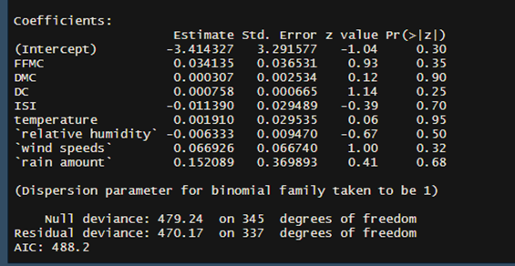

Figure 24: Logistic Regression Summary

Support Vector Machine

All four types (Linear, Polynomial, Radial, Sigmoid) of support vector machine kernels were used and compared. The models were ran and compared by accuracy and error type percentage.

Below(A) are the results to the Radial kernel SVM model. This model has a 51% accuracy and has a false negative prediction percentage of 55%. This model would be the best kernel to use.

Although it does not have the most accurate predictions it has significantly less false negative predictions.

Below(B) are the results to the Linear kernel SVM model. This model has a 54% accuracy and has a false negative prediction percentage of 71%.

** **

**A B**

Below(C) are the results to the Polynomial kernel SVM model. This model has a 60% accuracy and has a false negative prediction percentage of 86%.

Below(D) are the results to the Sigmoid kernel SVM model. This model has a 50% accuracy and has a false negative prediction percentage of 67%.

 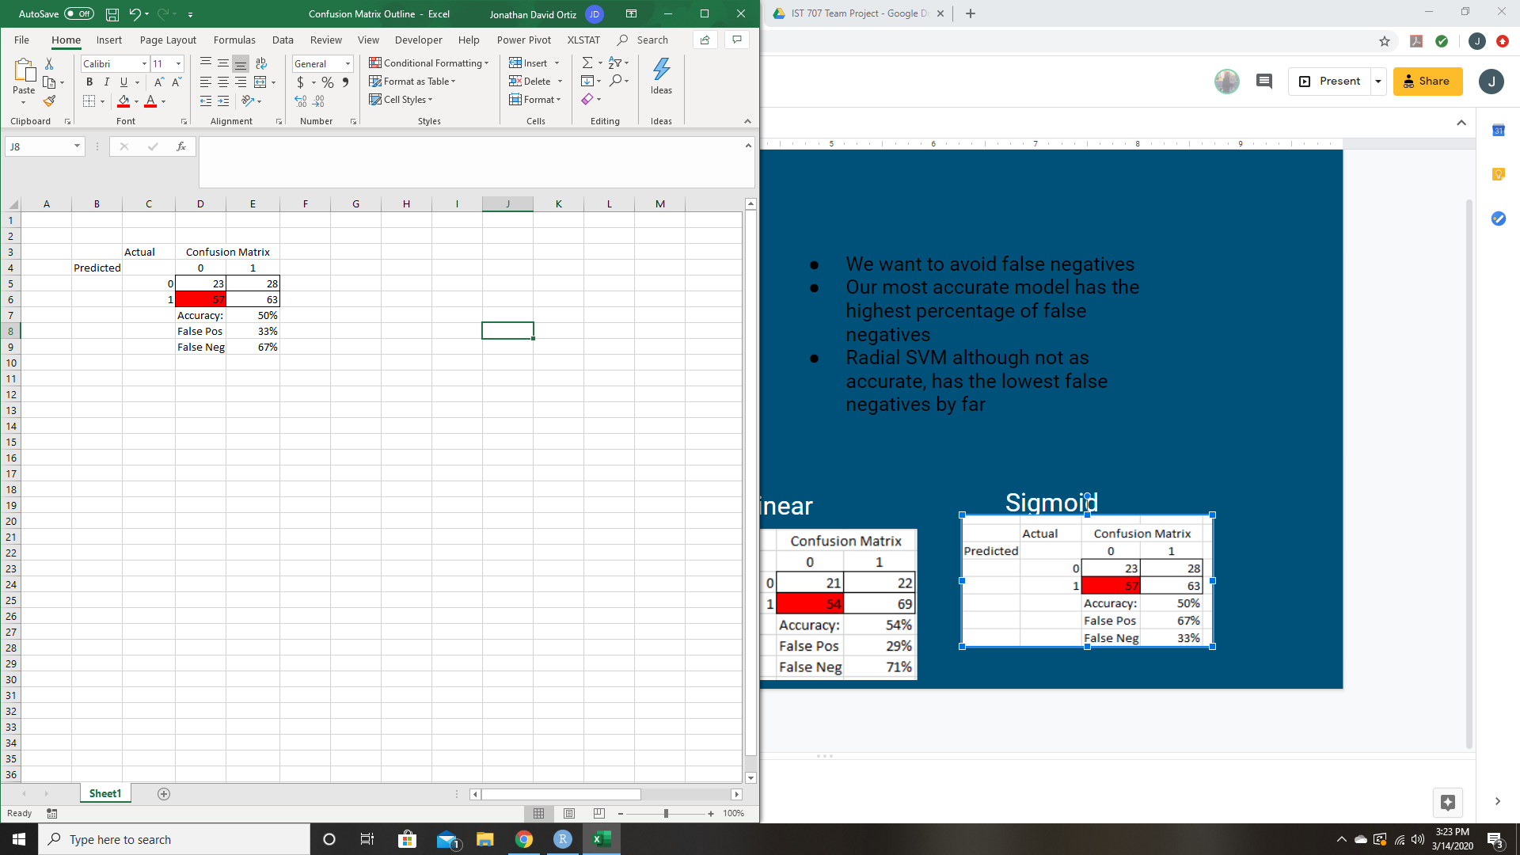

**C D**

Based upon the results obtained through the multiple models, predicting which fires would be significant is not entirely accurate with these techniques and data. Random forest had the strongest predictions out of the models tested. There is not one individual model that has outstanding results; however, a few learnings did take place. One learning is that seasonality plays an effect on predictability of significant fires.

Natural phenomenona could occur as outliers in the dataset. Other factors and data which could provide additional insight into forest fire prediction and strengthen the analysis would be data including lightning detection and when populations of campers were increased, leading to the possibility of accidental ignition from camp fires.

We worked tirelessly to have poorly performing models, but at the end of the day, we found many ways how not to conduct analysis going forward. To better predict the fires, lessen the damage, and control the significance of fires going forward, we concluded that better data collection is required. It was suggested to collect points in times when the park is the most populated because having this insight can create better parameters for future research.

# Develop a Plan of Action to Implement the Business Decisions derived from the Analyses

This learning objective was developed over many projects and assignments assigned during this program. I have been able to develop an understanding of what data means and how to develop a business plan of action to take advantage of those results. An example comes from my Scripting for Analytics class (IST 652). I was able complete a project using AirBnB data and suggest to stakeholder to market more to women in their 30’s during working hours. This was based on most of their bookings were made by the demographic selections initial users made when signing up for AirBnB. This conclusion could not have been reached without the techniques taught as mentioned in projects above.

# Demonstrate Communication Skills regarding Data and its Analysis

This learning objective has been mastered. All the projects undergone in this program have helped me develop skills in communication regarding data analysis. An example already given was from my Advanced Data Analytics class. UFO’s were a fun topic to learn about and analyze, but my partner and I had to also be able to professionally explain our process and results. Going through 10 datasets and explaining their significance and providing a somewhat legitimate answer to this extraterrestrial phenomenon was no small feat. This learning objective was demonstrated we were able to analyze the mounds of data we collected and were able to effectively communicate solid reasons as to why those particular events/attributes could and could not have resulted in a UFO sighting.

# Synthesize the E**thical Dimensions**of Data Science Practice

I had much less exposure to this learning objective throughout this program. I believe the closest I got to doing a project on this subject came from my Data Security class (IST 623). An important part of working with data is learning about data security. This is an entire subject that can take another two years to really get into, but I was able to get a glimpse into this field in a data security class. My biggest takeaway is that nothing online is ever really “safe.” Breaches happen all the time. Hackers are sleeplessly finding holes and back doors into applications to steal sensitive data. While it may seem fruitless to secure sensitive information, it is important to continually attempt to fix and patch applications and transfer of data. There are many obvious ways people use to access classified information such as phishing and other forms of social engineering, but it is very crucial that data scientists keep up to speed with security techniques and tools to better serve their organization as data guardians.

While this was in connection to our research on the Yahoo Data Breach where hundreds of millions of accounts and their data were compromised, we did discuss at length the duty of data scientists to always be thinking of ways to secure data.

An example of when this topic was discussed was in two of the classes mentioned above: Advanced Data Analytics and Advanced Text Mining. It was obvious with the text mining course that bias in news media was nearly inevitable, but it is something to always be aware of even in data science. The results and outcome of our analysis is a direct result of the information we use, and if we are collecting biased data, our results will be biased and therefore pose ethical dilemmas. It was made very clear to me from the start that ensuring the data collection process be as unbiased as possible. It is something to be conscious of, even though it is never perfect in practice.

In the Advanced Data Analytics Course, we underwent an self-driving vehicle mock test where we were to decide the outcome of various scenarios involving either breaking the law, hurting pedestrians, or hurting the driver. It was a fascinating exercise the opened our eyes to our own internal biases. Do we hit the homeless person or injure ourselves in a crash against the center divider? Which life is more important? While these questions seem extreme, they are real issues data scientists must face, and it was very insightful to gain insight into human thinking and behavior.